ADMOB INTEGRATION IN REACTNATIVE APP

First go to this link

<https://github.com/sbugert/react-native-admob>

then on terminal install the admob package through this command.

npm i --save react-native-admob@next

 then update your AndroidManifest.xml.

add this line in appliacation tag:

**<meta-data  
            android:name="com.google.android.gms.ads.APPLICATION_ID"  
            android:value="*ca-app-pub-xxxxxxxxxxxxxxxx~yyyyyyyyyy*"/>**

Like this:

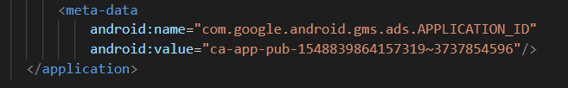

Now just run the app by:

npx react-native run-android.

Now you have integrated admob in your app.. now you can use as you want..

For Example banner ad:

import {

AdMobBanner,

AdMobInterstitial,

PublisherBanner,

AdMobRewarded,

} from 'react-native-admob'

// Display a banner

<AdMobBanner

adSize="fullBanner"

adUnitID="your-admob-unit-id"

testDevices={[AdMobBanner.simulatorId]}

onAdFailedToLoad={error => console.error(error)}

/>